# SANJALIKA WATERPARK SLIDE’S DESCRIPTION WITH MORE FEATURES

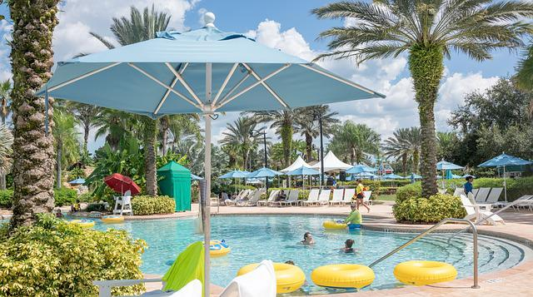

Figure sanjalika waterpark

Sanjalika Water Park is definitely an ultimate and out of the world source of entertainment. Decorated by mermaids, other statues, the Sanjalika Water park has largest cave and swimming pool area of modern technology a kind of place for thrills and fun. At Sanjalika Water park there is lot of water rides which are very exciting and thrilling.

In this document, you are gonna learn about more features of the slides with their information.

OCTOPUS SLIDE

Water parks are amusement parks that consist of lots of slides, playgrounds, swimming pools and lots of other areas which are full of water but are covered with various roundabouts. Water parks are mostly the favorite place to visit for every child and a lot of families during the summer visit various water parks as well. There are a lot of famous water parks around the world, and here a few of those water parks would be discussed where one can enjoy a **water park picnic** with his family.

FEATURES OF THE OCTOPUS SLIDE

Octopus Slide is one kind of water slide with combination of spiral tubes and multi-lane wave slides; we can supply the Whizzard slide with over three lanes per customer's request. One person one lane, visitors slide down from the closed spiral approach at the same time. After a circle of darkness, then the light comes next. It's the mutislide that meets the tourists. After the slide up and down, tourist finally falls into the falling pool. The whole journey is full of climax, which makes people forget to return.

MORE FEATURES

|  |  |
| --- | --- |
| **Width** | 0.6m |
| **Capacity** | 1person/lane |
| **Platform height** | 13.5m |
| **Stretched Length** | 110m |
| **Floor space** | 78m×25m |
| **Mats** | Yes |
| **Tubes** | No |
| **Rafts** | No |
| **Production Method** | RTM |

OCTOPUS SLIDE IMAGES

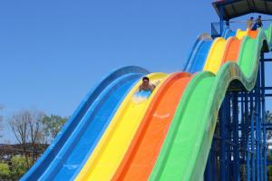

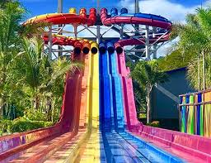

And many more images, customer feedback on such slides have always been good and keeps getting better.

Thank you!